Experimental and Humane Endpoints

I. Background
The Guide (p.27, 8th ed.): “Certain animal use protocols include procedures or approaches that require special consideration during the IACUC review process due to their potential for unrelieved pain or distress or other animal welfare concerns … the IACUC is obliged to weigh the objectives of the study against potential animal welfare concerns.”

AAALAC has developed FAQs to address the subtle reference to a Harm-Benefit assessment, “The 2011 Guide specifies that the Committee [IACUC] is obliged to weigh study objectives against animal welfare concerns in accordance with the tenets of the Three R’s. This analysis is typically already performed by IACUCs in their reviews of proposed animal studies. AAALAC International expects that IACUC’s (or comparable oversight body), as part of the protocol review process, will weigh the potential adverse effects of the study against the potential benefits that are likely to accrue as a result of the research. This analysis should be performed prior to the final approval of the protocol, and should be a primary consideration in the review process. For animal use activities potentially involving pain and/or distress or other animal welfare concerns, the AAALAC International site visitors will assess how the Committee conducts this analysis.”

II. Purpose:
The purpose of this document is to provide criteria for identifying and utilizing the earliest endpoints that are compatible with the scientific objective of research studies while preventing, minimizing, or alleviating any actual or potential pain, distress or discomfort to study animals.

III. Guidelines
Prodromata, Morbidity, Moribundity, Death: The earliest possible endpoint should be used. This may be prodromata (before specific clinical signs develop), morbidity (showing clinical signs), moribundity (an irreversible condition leading to death) or death as an endpoint. Some species (e.g., rodents) are prey species and therefore frequently appear normal and do not show clinical signs until they have significant compromise. The necessity of frequent and documented observations is vital, especially in some animal models where autolysis occurs in the morbidity/moribundity phase and progresses rapidly following death. Cage mate cannibalism may occur and complicate matters.

Pilot studies may play a critical role towards identifying pertinent and objective experimental and humane endpoints. Optimal endpoint parameters frequently require the researcher to improve understanding of the animal, animal model, and overall disease process, as various critical endpoint parameters may either go unrecognized (data not collected) or not curated (fine tuning an endpoint). Additionally, pilot studies can be pivotal to elucidating appropriate animal numbers.

The topic of Experimental and Humane Endpoints brings together several elements found in the Guide, including the following:
- Humane endpoints
- Cost-benefit (harm-benefit)
- 3Rs (specifically addressing experimental refinement and reduction in pain/distress)

The topic can broadly be separated into acute vs. chronic endpoints. Some animal models may unintentionally or unexpectedly develop rapidly, while the consideration for chronic endpoints (e.g., body condition scoring) may take days to weeks or longer to develop before a decision must be rendered (sometimes abruptly) to remove an animal from an experimental study. Regardless, an animal’s removal from a study minimizes the animal’s pain and distress and will likely enhance the data obtained vs. the animal dying and tissues being lost to cage mate cannibalism or autolysis, which occurs quite rapidly in many rodent species.

A host of criteria, generally behavior- or physiology-based, can and have been employed. Usually, a select single or limited combination of the following may be helpful. Again, pilot studies may be required or useful to identify and develop the most valuable experimental endpoints:
- Physical appearance and clinical signs are standard ill-health indicators: Includes hunched posture, dehydration, unwillingness to move, rough haircoat or ‘spikey’ fur, sunken eyes, and nasal or ocular discharge.
- Body condition/body condition scoring (BCS) is generally used when weight loss cannot be used or may give conflicting information; these research areas include tumor studies, ascites production, and gestational studies. Generally, over a protracted period, the body enters a catabolic wasting state from the loss of fat and lean body mass; therefore, BCS is generally a chronic indicator that may take weeks to develop and can be somewhat subjective. Table 1 below outlines a five-level, 1-5 scoring system where a lower number (e.g., BC 1) indicates animals are not thriving and in the poorest body condition, while higher numbers (up to BCS 5) indicate a better body condition. Unless otherwise approved by the IACUC, euthanize animal when they reach BCS 2.
- Physiology (e.g., body weight, body temperature, dehydration, oxygen saturation, biomarkers) Body weight and dehydration are closely linked in small rodent species (e.g., mice). Mice rapidly dehydrate and lose corresponding body weight, a condition compounded by renal failure a common condition in older mice (4-6 months). Additionally, mice have a short water cycle and must drink water daily. As mice lose body temperature, they will reach a point of no return where they can no longer maintain a normal body temperature, hypothermia develops, is irreversible, and once it falls below a critical point indicates an animal’s death several hours to days in advance. Hypothermia has significant animal welfare and research advantages over body condition scores.
- Paradigm-specific conditions (e.g., cancer; aging, Trammell et al., 2012)
- Unexpected research outcomes should be assessed as an endpoint/waypoint and used to reassess project elements or the whole project as this occurrence may indicated novel research altering elements have been introduced (e.g., human error).
- Animal model-specific conditions (e.g., mouse ulcerative dermatitis, background strain conditions) occur as part of an aging study or study involving a given mouse strain.

Table 1. Body Condition Score (BCS) Drawings and Descriptions
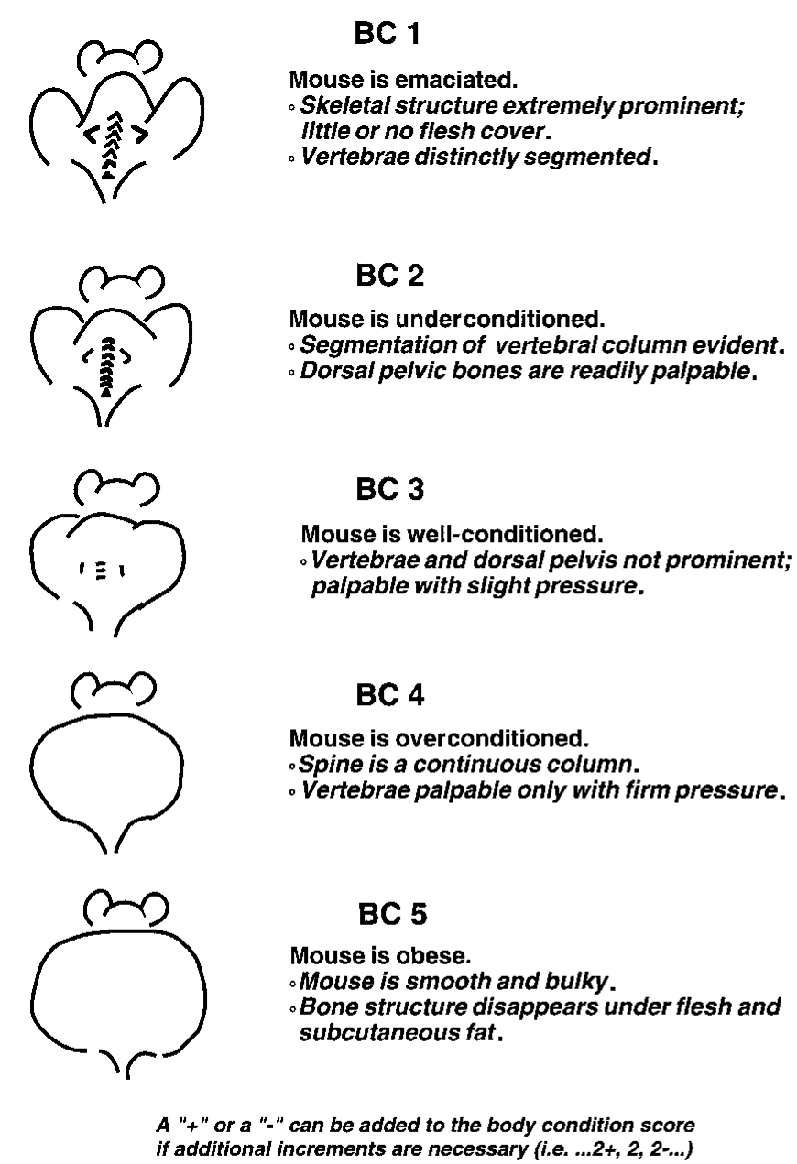
In either acute or chronic studies, researchers must understand the model as well as possible and intensify animal observations around critical timepoints. Animal observations are a critical component of the scientific process requiring documentation provided by the research staff, but may include the husbandry and veterinary staff contributing observations, assessments, and palliative care (e.g., fluid administration, placing wetted food on the cage floor). Additional animal observation may be required both during and outside regular business hours, including weekends and holidays. Whenever possible, the research timeline should be cognizant of when these critical experimental periods occur and avoid, to the best of their ability, holidays and weekends; likewise, surgical procedures should be avoided on Fridays and prior to holidays. If weekends, holidays, and after-hours assessments will occur, appropriate supplies must be available for treatment, euthanasia, tissue collection, etc. While it is understood that there may be requirements to conduct experiments during these inconvenient times, the research staff must communicate these intentions in advance so the research, husbandry and veterinary staff can coordinate activities to maximize the likelihood of positive research outcomes, including adequate patient care and essential data collection. Data collection would include prompt animal euthanasia, as well as proper communication of carcass identification, handling, and especially storage (e.g., refrigeration vs. freezing) when performed by animal care/veterinary staff.

Surrogate endpoints are biomarkers that are intended to substitute for a clinical endpoint. Perhaps most importantly, surrogate endpoints provide for the timely, antemortem sample collection that prevents data lost to autolysis, contamination, or cage mate cannibalism.

Researchers may find the following criteria can be used as surrogate endpoints in acute studies:
- General appearance
- Body weight
- Poor ability to ambulate
- Body temperature/Hypothermia1.

For chronic studies:
- Body weight
- Body temperature/Hypothermia
- Body condition scoring and body weight ± temperature
- Tumor size, ulceration, or interference with ambulation, feeding, etc.

There are reports of combining surrogate endpoints. Currently, the product of body temperature and body weight appear to hold the most value (Adamson, 2013; Ray, 2010; Trammell, 2012).

IV. Experimental and Humane Endpoint Examples
Body weight may be used as an endpoint alone or using a product of body weight and temperature being used. Generally, body weight loss of 10-20% is common.

Once animals meet or exceed a 10% body weight loss the research group is expected to discuss the weight loss with the veterinary staff towards mitigating further weight loss. The animal may be experiencing research-related or other issues that may be causing or compounding the experimental weight loss. Depending on the model, various treatments could be implemented permitting the animal’s weight and condition to rebound. A weight loss of 20% vs. age-matched controls generally necessitates euthanasia.

There are models, such as sepsis models, where weight gain was reported as a superior mortality indicator over weight loss (Nemzek et al., 2004).

When using body weight, benchmark weight loss against the animal’s original weight and age-matched controls (or vendor mouse line/background line information), with the latter being vital in studies lasting a week or more, or in young, postweanling animals. This information is summarized for C57BL/6J mice in Appendix A. Meeting or exceeding the IACUC-approved endpoint warrants euthanasia.

Increased water consumption was a key marker for Huntington’s Disease suggesting vasopressin dysregulation related to hypothalamic vasopressin release, which contributed to weight loss by impacting food taste, mastication, and swallowing.

Hypothermia offers an objective marker indicating progression from various insults (e.g., sepsis, infectious disease), the progression of those insults, and animal death. Hypothermia has been used successfully as a surrogate endpoint or heightened monitoring trigger in a variety of experimental models, including aging; infectious agents (bacteria, fungi, viruses); LPS/sepsis; and tumor progression. Table 2, below, outlines the temperature devices, endpoints and types of studies using hypothermia as an endpoint.

Temperature-related endpoints may be established/validated for each experimental model; however, this can occur alongside existing endpoints as not to impede protocol approval. Animal stock or strain could impact the actual endpoint.

Tumors are most easily assessed by size (up to 1.5 cm in mice, 2 cm in rats across the largest dimension); interference with an animal’s ability to ambulate; eat or drink; obstructs or restricts a body orifice; or other negative impacts on activity or body functions; or causes pain, discomfort, or distress. Euthanize animals with the preceding; additionally, animals must be euthanized before or when the tumor becomes ulcerated, which is evident by skin disruption to any degree.

Those tumors occurring/induced in a body cavity will require assessment of organ system-specific clinical signs (e.g., neurologic deficits), the animals general appearance, and any other relevant criteria.

Cell lines and tumors employed require assessment for murine and human pathogens (if applicable), as well as authenticity.

Pulse oximetry is a noninvasive technology providing a rapid assessment of the blood’s oxygen saturation level expressed as a percent. This technology can be leveraged as an endpoint for those studies where respiratory compromise occurs. Oxygen saturation levels less than 95% indicate significant respiratory dysfunction.

Imaging provides an objective, serial, visual measure of a tumor’s state. It is particularly helpful in orthotropic tumor implants in body cavities that are poorly visualized (e.g. cranium, thorax, abdomen). Various imaging methods may be beneficial to assess tumor progression and metastasis.

Biomarkers provide objective, serial, clinical measures of an animal’s biologic state and over time, disease progression. The markers may be used alone, or in combination with other items or factors to assess an animal’s health or disease state. There are a variety of biomarkers for various biologic systems.

Table 2. Studies using hypothermia as an experimental or humane endpoint.
Study Type | Temperature (°C) | Device | Reference (PMID)
Aging
Used a body weight x temperature metric | Temperatures fell by more than 1 °C the final few weeks of life | SQ Microchip | 20587157
Used a body weight x temperature metric | Temperatures fell by more than 1 °C the final few weeks of life | SQ Microchip | 22776049
Bacteria
Vibrio vulnificus | ≤23.5 | IR Thermometer at the sternal base | 28629317
P. aeruginosa  S. aureus  S. epidermidis | 34 | Rectal probe | 1576081
K. pneumoniae | 36 | SQ/IP Microchip | 9718473
Streptococcus pneumoniae | Temperature x Body Weight < 90% of baseline | SQ Microchip | 22330575
Fungal
Aspergillus fumigatus | 29.0 | IR Thermometer at the lower abdomen | 24326222
Candida albicans | 33.3 | SQ Microchip | 12689423
LPS/Sepsis
— | <30 or body temperature reduction by >5 | Rectal probe | 30054760
— | 24.3 | Noncontact thermometer, perianal | 29476115
Tumor Progression
Used a body weight x temperature metric | Hypothermia used to intensify monitoring (1 °C) or euthanasia (>3 °C) | SQ Microchip | 22776049
Viral
Influenza | ≤ 32 °C | Rectal probe | 9150492

V. References
- AAALAC FAQs. (n.d.). AAALAC. Retrieved May 26, 2020, from https://www.aaalac.org/accreditation-program/faqs/#B3

- Adamson, TW; et al. 2013. Hypothermic Endpoint for an Intranasal Invasive Pulmonary Aspergillosis Mouse Model. Comp Med, 63(6):477-481.

- Beamer, GL; et al. 2008. Peripheral Blood Gamma Interferon Release Assays Predict Lung
- Responses and Mycobacterium tuberculosis Disease Outcome in Mice. Clin Vaccine Immunol, 15(3):474-483.

- Food and Drug Administration. 2020. Biomarkers and Surrogate Endpoints in Clinical Studies to Support Effectiveness of New Animal Drugs. Guidance for Industry Draft Guidance.

- Foltz, CJ; Ullman-Culleré, MH. 1999. Guidelines for Assessing the Health and Condition of Mice. Lab Anim (NY), 28(4):28-32.

- Franco, NH; et al. 2012. How ‘‘Humane’’ Is Your Endpoint?—Refining the Science-Driven Approach for Termination of Animal Studies of Chronic Infection. PLoS Pathog 8(1) e1002399.

- Gavin, HE; Satchell, KJF. 2017. Surface hypothermia predicts murine mortality in the intragastric Vibrio vulnificus infection model. BMC Microbiol, 17(1):136.

- Kort, WJ; et al. 1998. A microchip implant system as a method to determine body temperature of terminally ill rats and mice. Lab Anim, 32(3):260-269.

- Littin, K; et al. 2008. Towards humane end points: behavioural changes precede clinical signs of disease in a Huntington’s disease model. Proc R Soc B, 275:1865-1874.

- Mai, SHC; et al. 2018. Body temperature and mouse scoring systems as surrogate markers of death in cecal ligation and puncture sepsis. Intensive Care Med Exp, 6(1):20

- Mei, J; et al. 2018. Body temperature measurement in mice during acute illness: implantable temperature transponder versus surface infrared thermometry. Sci Rep, 8(1):3526.

- National Research Council. 2011. Guide for the Care and Use of Laboratory Animals: Eighth Edition. Washington, DC: The National Academies Press.

- National Research Council. 2009. Recognition and Alleviation of Pain in Laboratory Animals. Washington, DC: National Academies Press.

- Nemzek et al. 2004. Humane Endpoints in Shock Research. Shock 21(1):17-25.

- Ray, MA; et al. 2010. Identification of Markers for Imminent Death in Mice used in Longevity and Aging Research. J Am Assoc Lab Anim Sci, 49(3):282-288.

- Schaecher, K; et al. 2005. Genome-Wide Expression Profiling in Malaria Infection Reveals Transcriptional Changes Associated with Lethal and Nonlethal Outcomes. Infect Immune, 73(9):6091-6100.

- Soothill, JS; et al. 1992. The HID₅₀ (hypothermia-inducing dose ₅₀): an alternative to the LD₅₀ for measurement of bacterial virulence. Int J Exp Pathol, 73(1):95-98.

- Trammell, RA; et al. 2012. Markers for Heightened Monitoring, Imminent Death, and Euthanasia in Aged Inbred Mice. Comp Med, 62(3):172-178.

- Trammell, RA; Toth, LA. 2011. Markers for Predicting Death as an Outcome for Mice Used in Infectious Disease Research. Comp Med, 61(6):492-498.

- Ullman-Culleré, MH; Foltz, CJ. 1999. Body Condition Scoring: A Rapid and Accurate Method for Assessing Health Status in Mice. Lab Anim Sci, 49(3):319-323.

- Verhoeven, D; et al. 2009. Pulse-oximetry accurately predicts lung pathology and the immune response during influenza infection. Virology, 390:151-156.

- Warn, PA; et al. 2003. Infrared body temperature measurement of mice as an early predictor of death in experimental fungal infections. Lab Anim, 37(2):126-131.

- Wong, JP; et al. 1997. Development of a murine hypothermia model for study of respiratory tract influenza virus infection. Lab Anim Sci, 47(2):143-147.
Appendix A: Mouse Line Body Weight Information

Weekly Body Weight Information for C57BL/6J Mice.
Age (w) | Body Weight (g) |  | Weekly ∆g |  | Weekly ∆%
 | ♀︎ | ♂︎ | ∆g ♀︎ | ∆g ♂︎ | ∆% ♀︎ | ∆% ♂︎
3 | 10.1 | 10.6 | — | — | — | —
4 | 14.7 | 16.5 | 4.6 | 5.9 | 45.5% | 55.7%
5 | 17.8 | 20.7 | 3.1 | 4.2 | 21.1% | 25.5%
6 | 18.5 | 21.9 | 0.7 | 1.2 | 3.9% | 5.8%
7 | 19 | 23.6 | 0.5 | 1.7 | 2.7% | 7.8%
8 | 19.6 | 25 | 0.6 | 1.4 | 3.2% | 5.9%
9 | 20.3 | 26.1 | 0.7 | 1.1 | 3.6% | 4.4%
10 | 20.7 | 26.9 | 0.4 | 0.8 | 2.0% | 3.1%
11 | 21.3 | 27.7 | 0.6 | 0.8 | 2.9% | 3.0%
12 | 21.9 | 28.9 | 0.6 | 1.2 | 2.8% | 4.3%
13 | 22.6 | 30 | 0.7 | 1.1 | 3.2% | 3.8%
14 | 23 | 30.8 | 0.4 | 0.8 | 1.8% | 2.7%
15 | 23.5 | 31.6 | 0.5 | 0.8 | 2.2% | 2.6%
16 | 23.9 | 32.1 | 0.4 | 0.5 | 1.7% | 1.6%
17 | 24.1 | 32.8 | 0.2 | 0.7 | 0.8% | 2.2%
18 | 24.5 | 33.3 | 0.4 | 0.5 | 1.7% | 1.5%
19 | 24.8 | 33.7 | 0.3 | 0.4 | 1.2% | 1.2%
20 | 25.3 | 34.2 | 0.5 | 0.5 | 2.0% | 1.5%
21 | 25.8 | 34.6 | 0.5 | 0.4 | 2.0% | 1.2%
22 | 26.1 | 35.1 | 0.3 | 0.5 | 1.2% | 1.4%
23 | 26.5 | 35.8 | 0.4 | 0.7 | 1.5% | 2.0%
24 | 26.9 | 36.3 | 0.4 | 0.5 | 1.5% | 1.4%
Average |  |  | 0.8 | 1.2

